**Fissure Simulation**

Group 7

Amod Karambelkar

Ashna Gupta

Deepti Rana

Gaurang Agarwal

Sriram Subramanyan

**Sprint 0 - Week 1 (Possible Points: 4)**

**Sprint Backlog (1 Point)**

* Paste the screen shot of your Sprint Backlog below **(1 Point):**

**Answer**

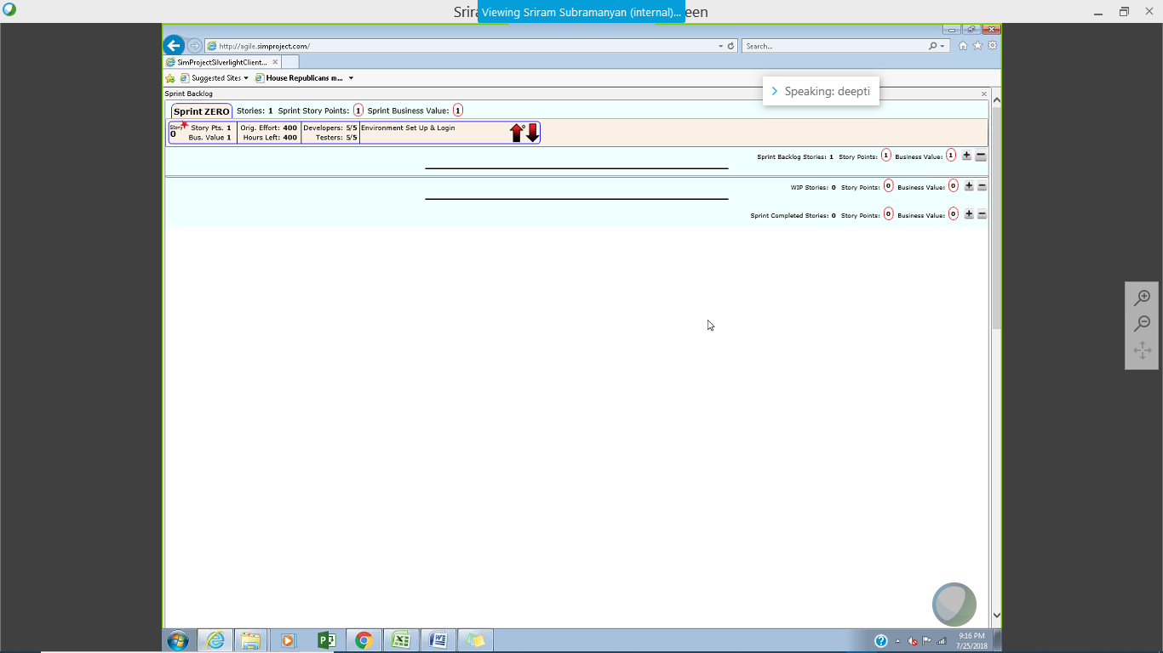

**Task Board (1 Point)**

* Paste the screen shot of your Task Board (at the end of this Sprint) below**(1 Point):**

**Answer**

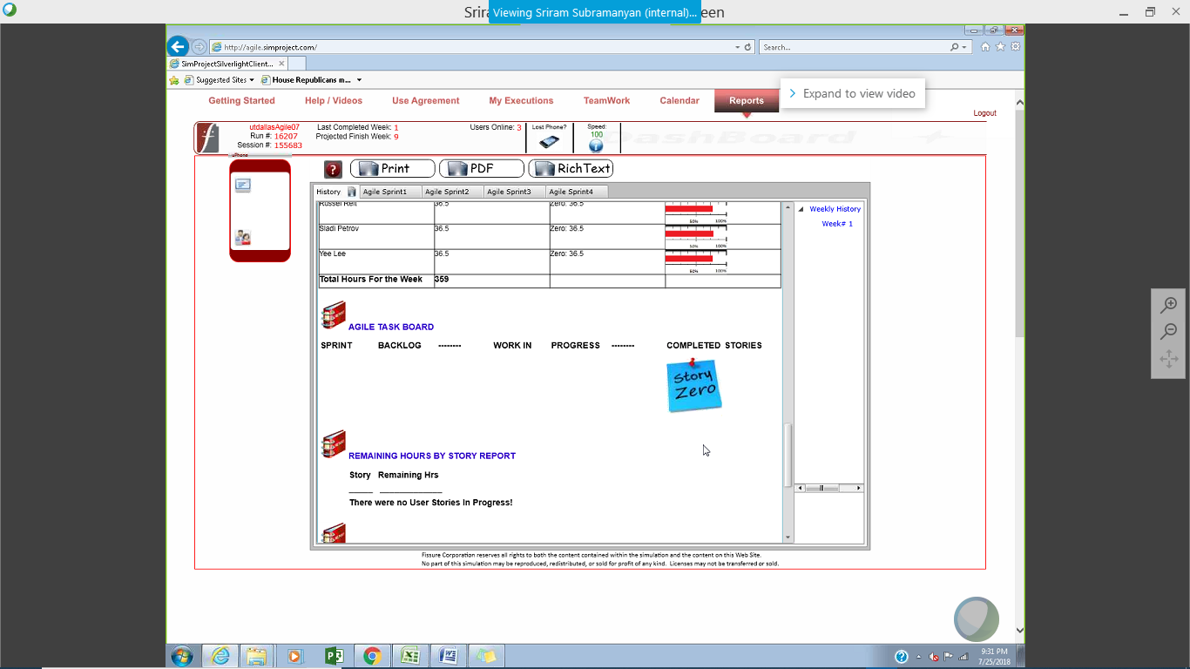

**BurnDown – EarnUp Chart (2 Points)**

* Be sure to complete your BurnDown – EarnUp Chart for this sprint. An Excel template has been provided for these charts.
* Paste the Sprint 0 Burn Down – Earn Up Chart below:

**Answer**

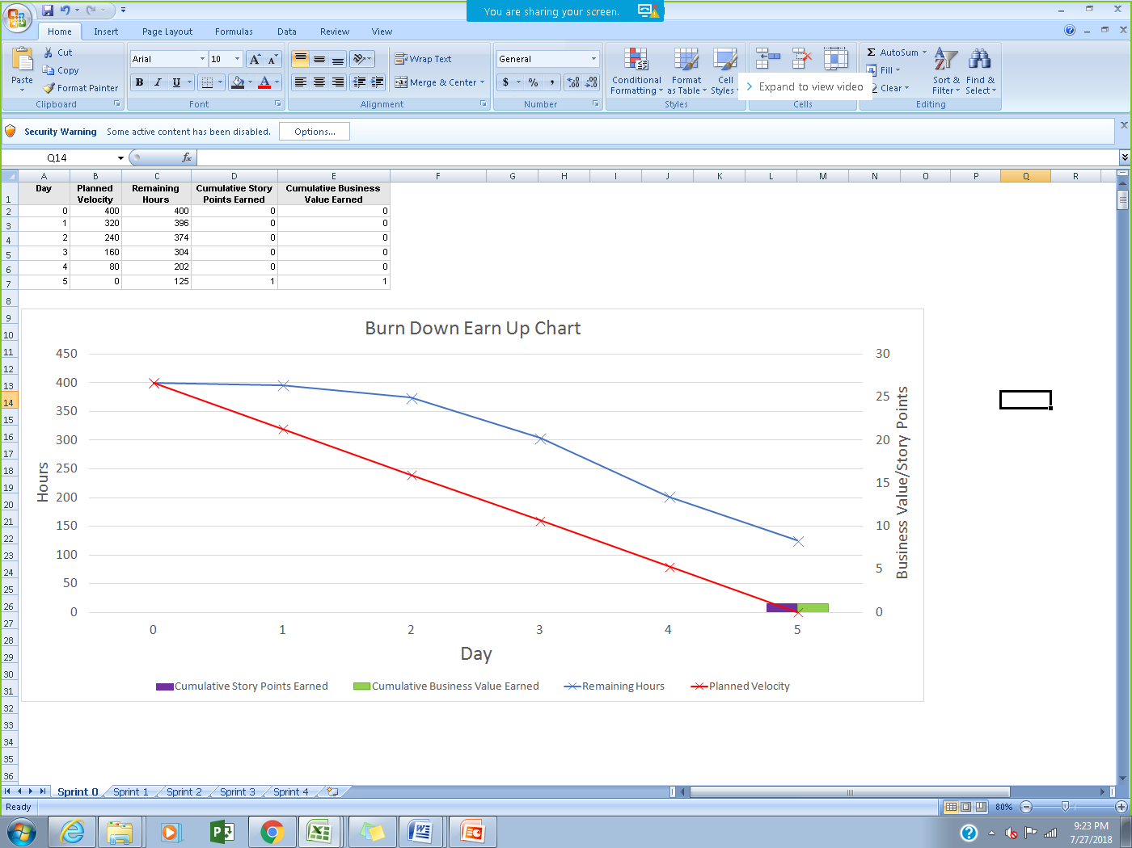

**Sprint 1 - Week 2 & Week 3 (Possible Points: 24)**

**Product Backlog (one screen shot for both weeks)**

* Paste the screen shot of your Product Backlog below **(1 Point)**:

**Answer**

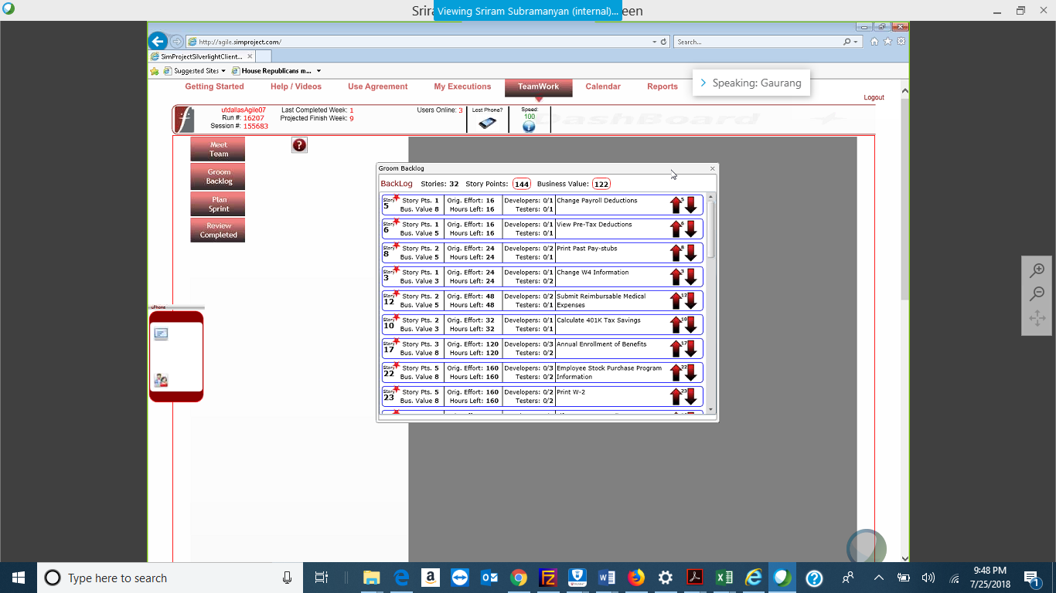

* Please explain what you did in grooming the user stories in your Product Backlog and your reasoning for these decisions **(2 Points):**

**Answer**

First, we created an additional attribute, Business Value/total hours. We then sorted, max-low, the PBI based on Business Value/total hours. The priority was to finish must have user stories and then the user stories with higher business value/total hours and story points.

As per our calculation and accommodating different reasons for time slips, the two-week sprint could finish user stories requiring approximately 720 work hours. At this point, we had to move user story 15 to sprint 2, ensuring we do not schedule number of sprints more than what could finish in the sprint. Moreover, due to limited resources, we were forced to further prioritize the PBI.

**Sprint Backlog (one screen shot for both weeks)**

* Paste the screen shot of your Sprint Backlog below **(1 Point):**

**Answer**

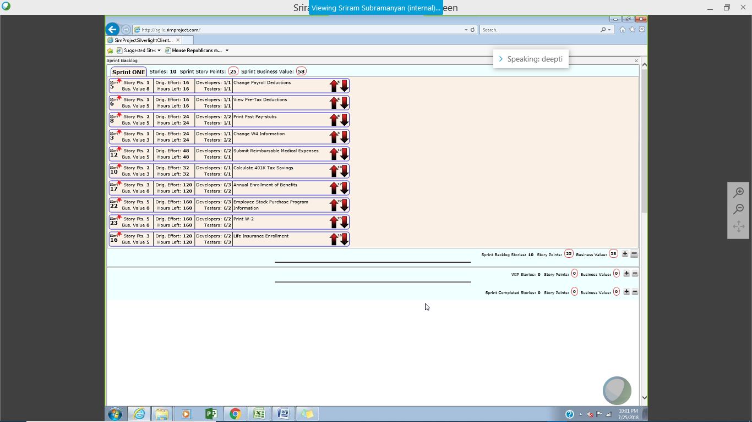

**Calendar**

* Paste the screen shot of your Calendar (one screen shot for 1st week & one for 2nd week):

1st Week Calendar Screen Shot and explain the reason why you have scheduled these meetings (if any)? **(2 Points)**

**Answer**

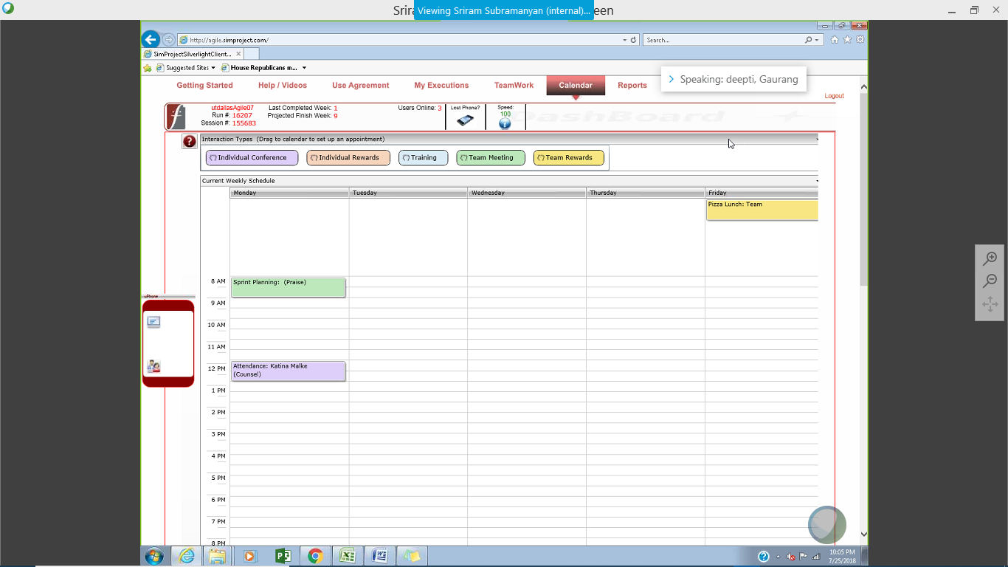

The meetings are:

* Sprint planning: To plan the product backlog items so we can get a Sprint backlog. It shows a list of all user stories expected to be completed by the team.
* Attendance: We scheduled counseling session for Katina because of her uncalled absence in the prior week.
* Team Rewards: We also scheduled a team lunch on Friday for successful implementation of User Stories in Week 1. This also helps in team bonding & is a good way to promote team building

2nd Week Calendar Screen Shot and explain the reason why you have scheduled these meetings (if any)? **(2 Points)**

**Answer**

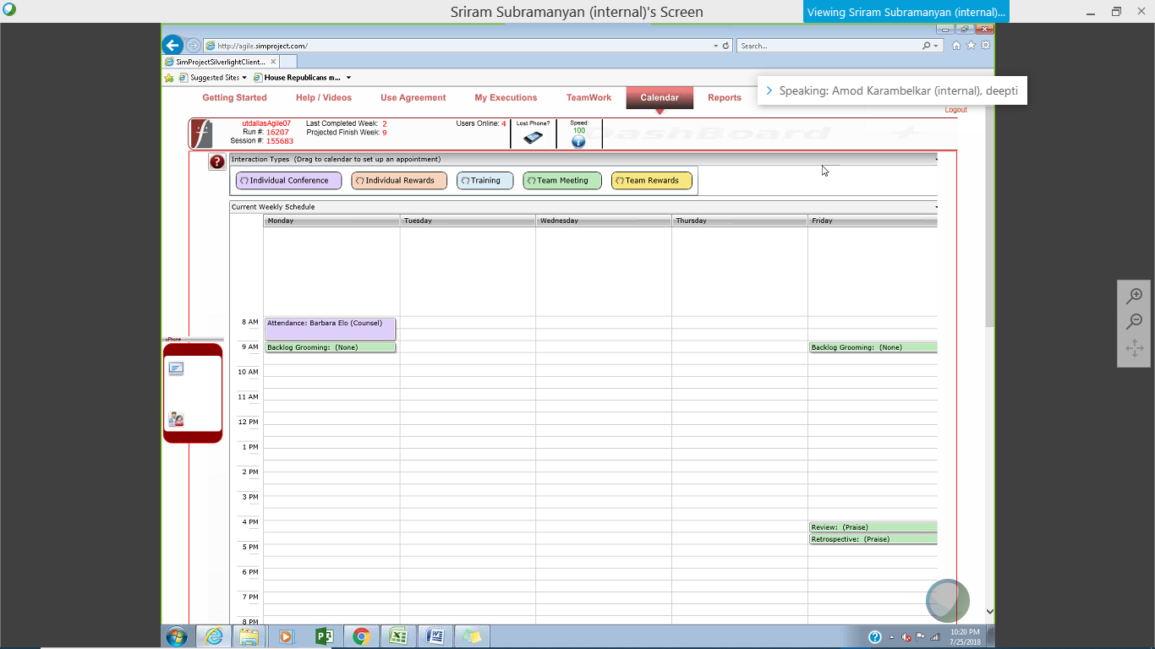

The meetings are:

* Attendance: We scheduled counseling session for Barbara, because she worked for less hours and had low productivity.
* Backlog Grooming: This meeting was to prepare the product backlog items for the next week. We have two 30-minute sessions spread out across the week.
* Sprint Review: The review meeting was to discuss the user stories completed and discuss about the overall product.
* Sprint Retrospective: The review meeting was to see what processes to improve for the next Sprint and rectify mistakes made in the current Sprint.

**Task Board**

* Paste the screen shots of your Task Boards (one screen shot for 1st week & one for 2nd week):

1st Week Task Board Screen Shot **(1 Point):**

**Answer**

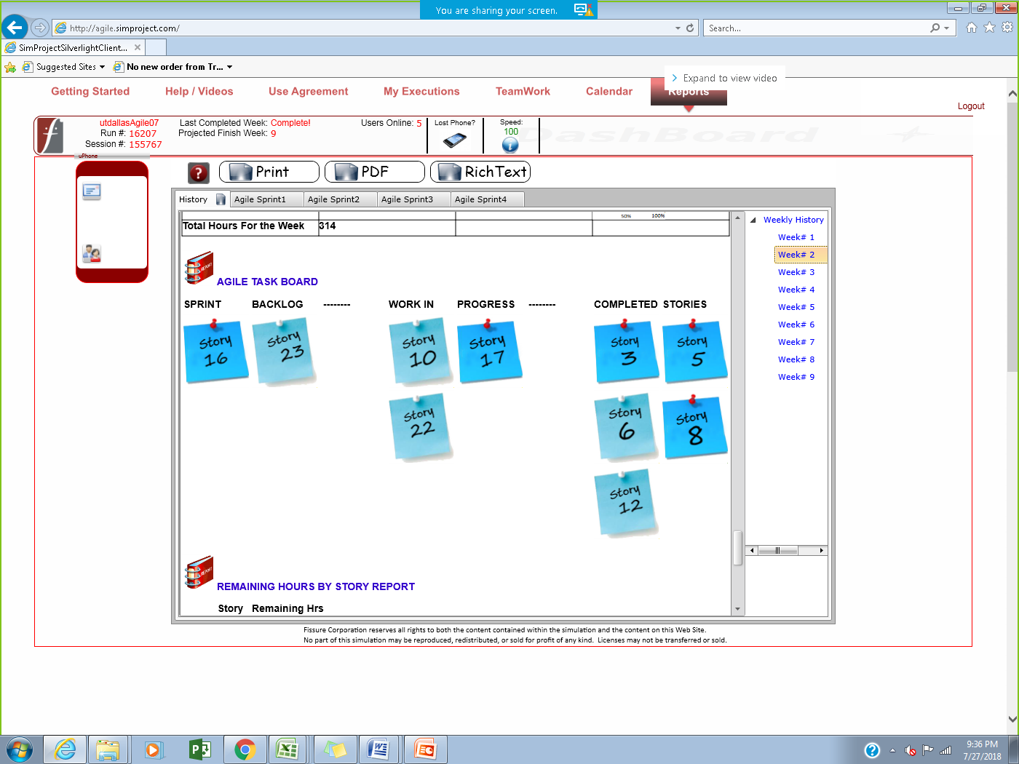

2nd Week Task Board Screen Shot **(1 Point):**

**Answer**

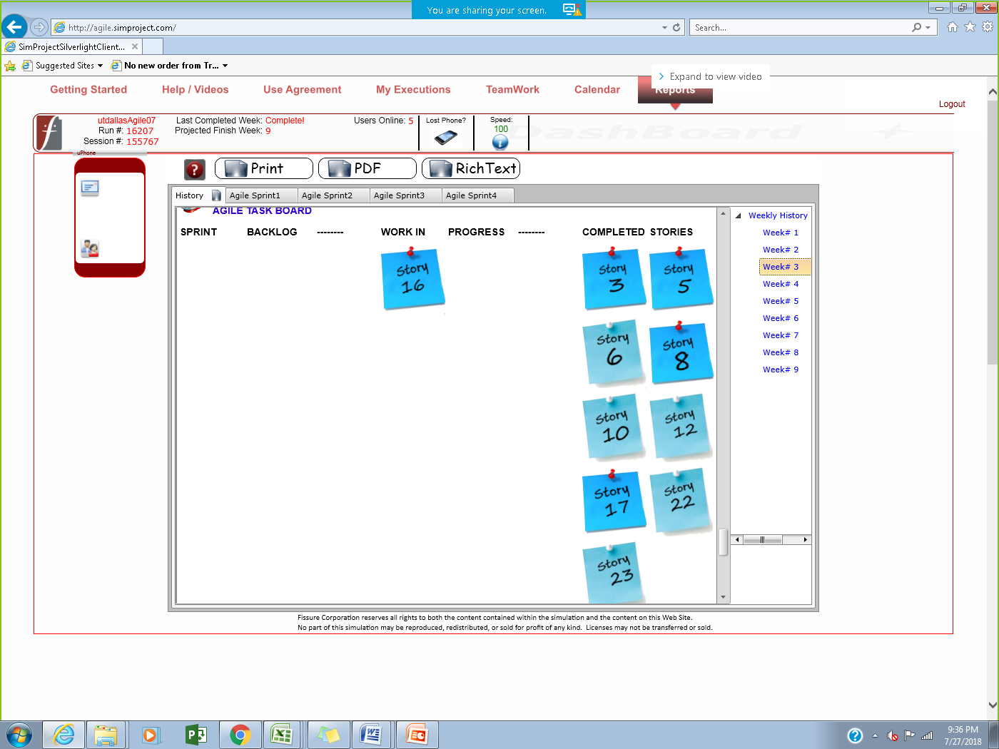

**BurnDown – EarnUp Chart**

* Be sure to complete your Burn Down – Earn Up Chart for this sprint. An Excel template has been provided for these charts.
* Paste the Sprint 1 Burn Down – Earn Up Chart below **(2 Points)**:

**Answer**

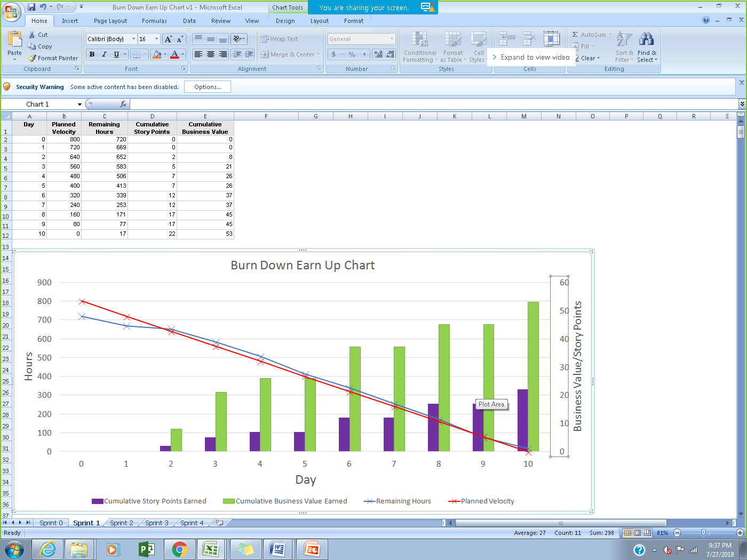

**Retrospective Meeting:**

* How did you do in this Sprint? **(2 Points)**

**Answer**

Out of the planned 720 hours of work we were able to complete 703 hours. For the first sprint with the team, our forecasted velocity was sufficiently good. Once we have more historical data, our projections should improve.

* What changes you are planning to make in the next Sprint (if any)? **(2 Points)**

**Answer**

We are planning to schedule less than 720 hours of work and set aside even more time for other activities for the employees. Since the absent rate was 2-3% and attrition was 4-5% we had to take this into account while planning for the next Sprint.

**Answer following questions based on this Sprint:**

1. How many hours did your team complete each week in the two weeks of above Sprint? What is your average velocity per week (in hours), and your velocity range (in hours per week), using the lowest and highest hours/week as your range? **(2 Points)**

**Answer**

In week 2: 720-413 = 307 hours of work

In week 3: 413- 17 = 396 hours of work

Average velocity per week in hours (for Sprint 1)= 307+396/2=351.5 hours of work

Average velocity per week in hours (cumulative)= 275 + 307+396 / 3 = 326 hours of work (We also took the velocity of week 1 into the average calculation)

Velocity range = 275 to 396 hours (We considered velocity of Week 1 into the range calculation)

2. What is your velocity (in story points) for above Sprint? **(2 Points)**

**Answer**

**Velocity is 22 story points**

3. Based on the current status of your project, do you believe that you will be able to complete the mandatory (or required) stories in the product backlog within the four sprints planned following Sprint Zero?  Explain your answer. **(2 Points)**

**Answer**

Yes, the required functionalities require 42 story points worth of work to be delivered. If our current velocity is an indication of future sprints, we will be able to finish these in Sprint 2.

4. Based on the current status of your project, do you believe that you will be able to complete all stories in the product backlog within the four sprints planned following Sprint Zero? Explain your answer. **(2 Points)**

**Answer**

No. The story points in the backlog require 145 story points to be delivered. If we maintain our current pace, we would only be able to deliver a total of 88 story points in 4 sprints.

**Sprint 2 - Week 4 & Week 5 (Possible Points: 24)**

**Product Backlog (one screen shot for both weeks)**

* Paste the screen shot of your Product Backlog below **(1 Point)**:

**Answer**

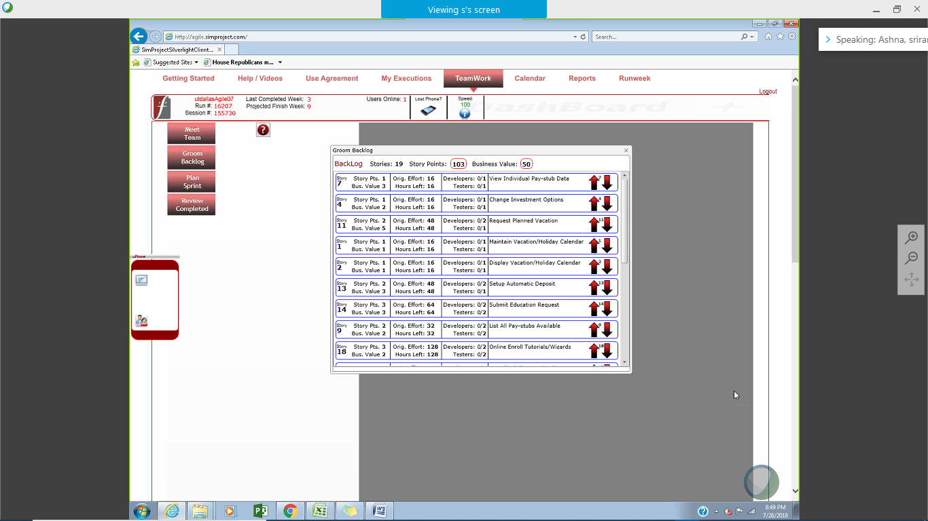

* Please explain what you did in grooming the user stories in your Product Backlog and your reasoning for these decisions **(2 Points)**:

**Answer**

Our capacity is more than the effort required to deliver the required user stories.

Hence, we gave MRFs top priority and then picked up other stories by ranking them on business value/number of hours of effort**.**

**Sprint Backlog (one screen shot for both weeks)**

* Paste the screen shot of your Sprint Backlog below **(1 Points)**:

**Answer**

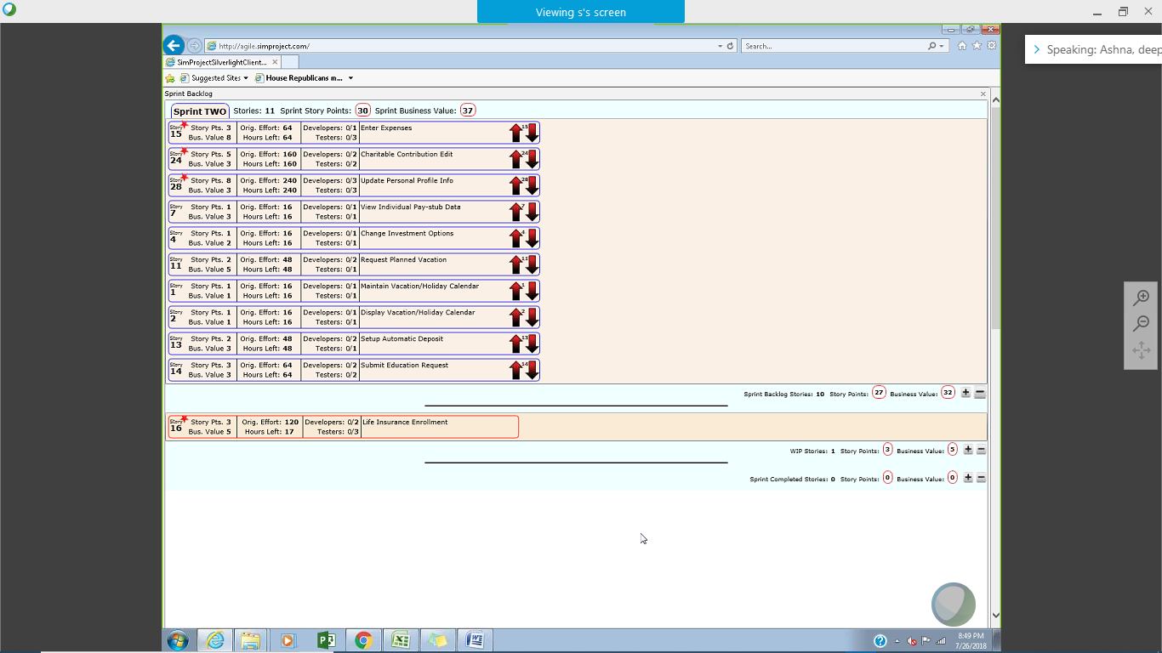

**Calendar**

* Paste the screen shot of your Calendar (one screen shot for 1st week & one for 2nd week):

1st Week Calendar Screen Shot and explain the reason why you have scheduled these meetings (if any)? **(2 Points)**

**Answer**

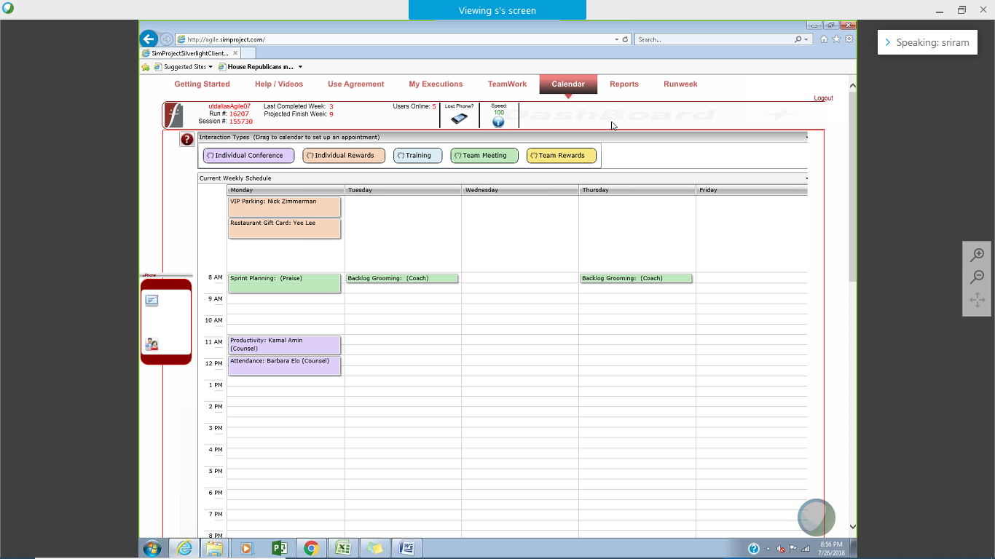

The meetings are:

* Sprint planning: To plan the product backlog items so we can get a Sprint backlog. It shows a list of all user stories expected to be completed by the team during the current Sprint.
* Attendance: We scheduled counseling session for Barbra because she did not attend the Sprint review and retrospective meeting at the end of the previous Scrum.
* Productive meeting: Kamal’s productivity was lower compared to other team members (worked only 22hours during the previous week)
* Individual Rewards: We rewarded Nick and Yee for their outstanding contribution in the previous Sprint.
* Backlog Grooming: This meeting was to prepare the product backlog items for the next week. We have two 30-minute sessions spread out across the week.

2nd Week Calendar Screen Shot and explain the reason why you have scheduled these meetings (if any)? **(2 Points)**

**Answer**

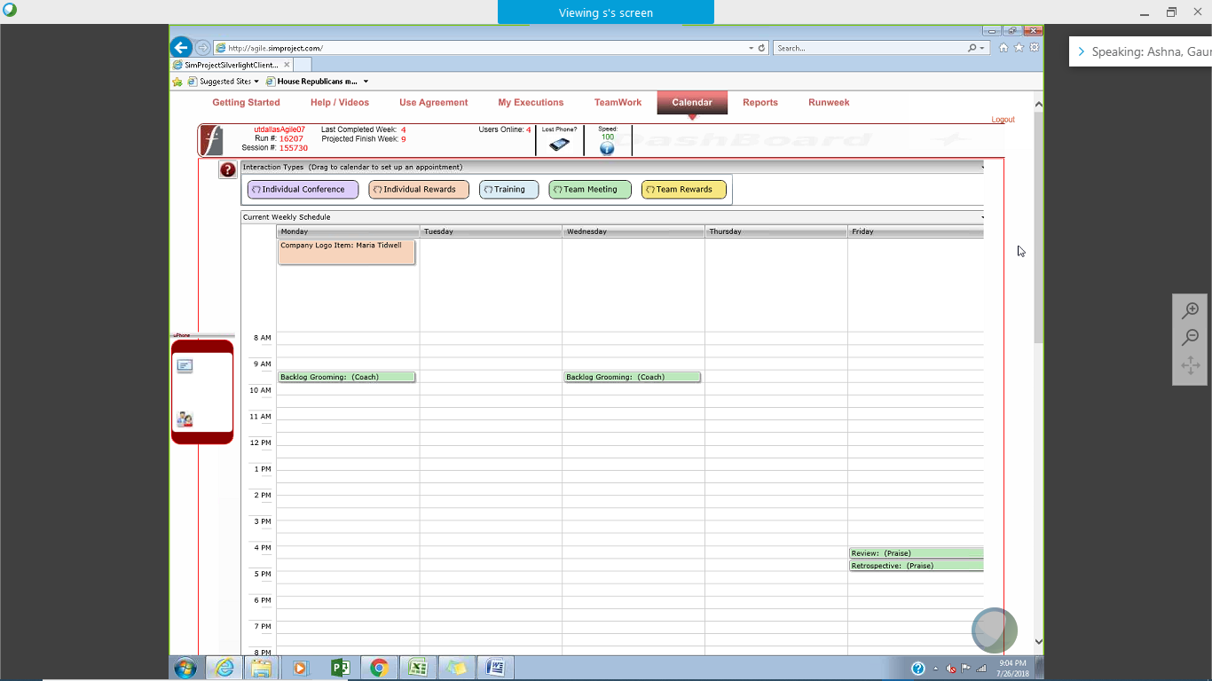

The meetings are:

* Backlog Grooming: This meeting was to prepare the product backlog items for the next week.
* Individual Rewards: We rewarded Maria for showing high productivity during the first week of the ongoing Scrum.
* Sprint Review: The review meeting was to discuss the user stories completed and discuss about the overall product.
* Sprint Retrospective: The review meeting was to see what processes to improve for the next Sprint and rectify mistakes made in the current Sprint.

**Task Board**

* Paste the screen shots of your Task Boards (one screen shot for 1st week & one for 2nd week):

1st Week Task Board Screen Shot **(1 Points)**:

**Answer**

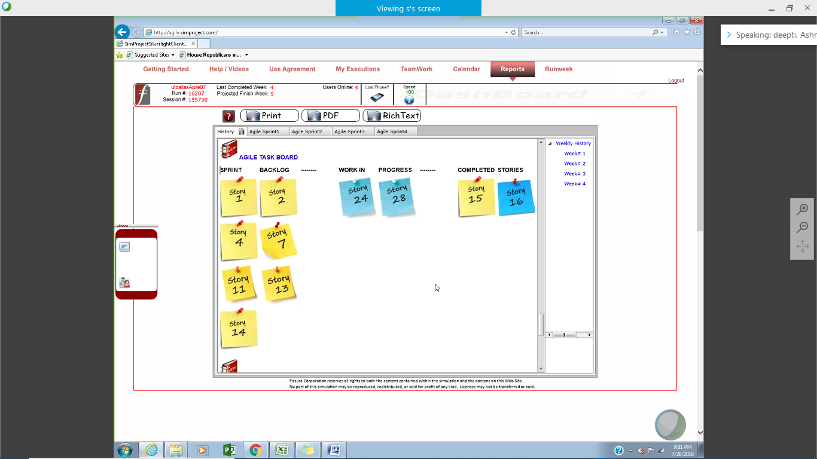

2nd Week Task Board Screen Shot **(1 Points)**:

**Answer**

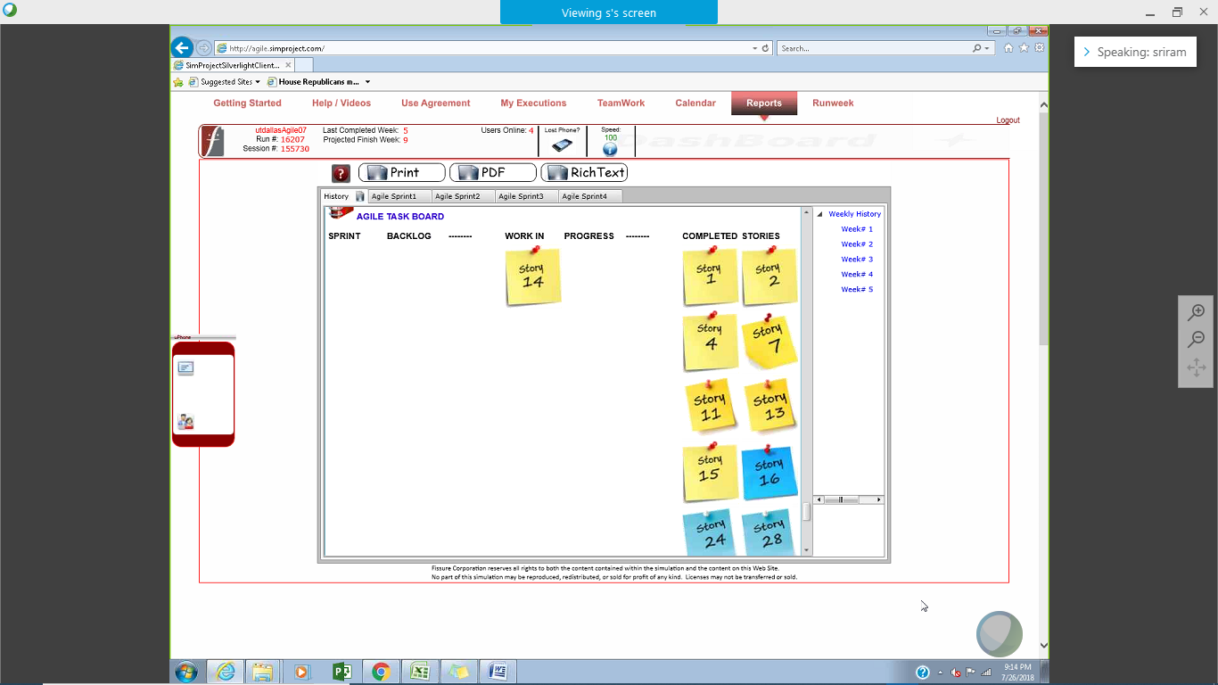

**BurnDown – EarnUp Chart**

* Be sure to complete your Burn Down – Earn Up Chart for this sprint. An Excel template has been provided for these charts.
* Paste the Sprint 2 Burn Down – Earn Up Chart below **(2 Points)**:

**Answer**

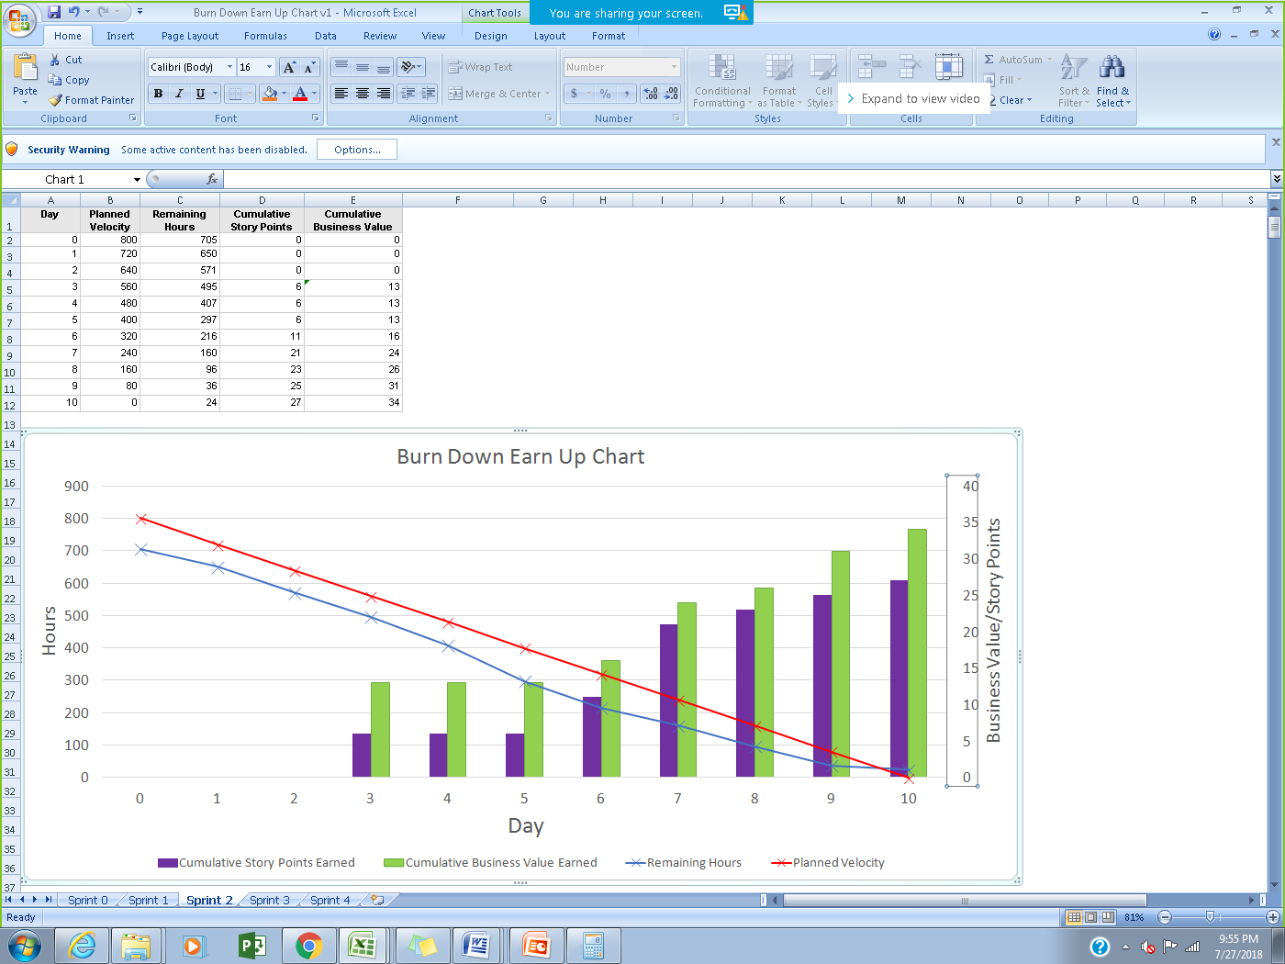

**Retrospective Meeting:**

* How did you do in this Sprint? **(2 Points)**

**Answer**

Even though we tried to plan for lesser number of hours (we fell short by 17 hours last sprint) but we still fell short by 24 hours this sprint. This was because we didn’t plan for Barbara leaving the entire project team.

We managed to finish required stories and will start working on nice to have user stories during the next Sprint.

* What changes you are planning to make in the next Sprint (if any)? **(2 Points)**

**Answer**

The following changes will be made in next Sprint and its planning:

* Plan in detail about activities that can cause delay in sprint completion or reduction in productivity Include less user stories/required work hours
* Rework daily scrum meeting and sprint retrospective to make them more useful
* Plan for individual and team rewards

**Answer following questions based on above Sprint:**

1. How many hours did your team complete each week in the two weeks of above Sprint?   
   What is your average velocity per week (in hours), and your velocity range (in hours per week), using your lowest and highest hours/week in this project? **(2 Points)**

**Answer**

In week 4: 408

In week 5: 384

Average velocity per week in hours (for Sprint 2)= 408+384/2=396 hours of work

Average velocity per week in hours (cumulative): 384+408+307+396+275/5 = 354 hours of work (We also took the velocity of Sprint 0 & 1 into the average calculation)

Velocity range: 275 to 408 hours per week

2. What is your velocity (in story points) for this Sprint? **(2 Points)**

**Answer**

We delivered 27 story points in this sprint.

Overall velocity range = 22 to 27

3. Based on the current status of your project, do you believe that you will be able to complete the mandatory (or required) stories in the product backlog within the remaining sprints?  Explain your answer. **(2 Points)**

**Answer**

We have already delivered mandatory stories and they have been accepted by the product owner.

4. Based on the current status of your project, do you believe that you will be able to complete all stories in the product backlog within the remaining sprints? Explain your answer. **(2 Points)**

**Answer**

No. From Sprint 1 and 2, our average velocity is 24.5. In 4 sprints, we will only be able to deliver around 98 story points. Delivering all stories requires work on 145 story points.

**Sprint 3 - Week 6 & Week 7 (Possible Points: 24)**

**Product Backlog (one screen shot for both weeks)**

* Paste the screen shot of your Product Backlog below **(1 Point)**:

**Answer**

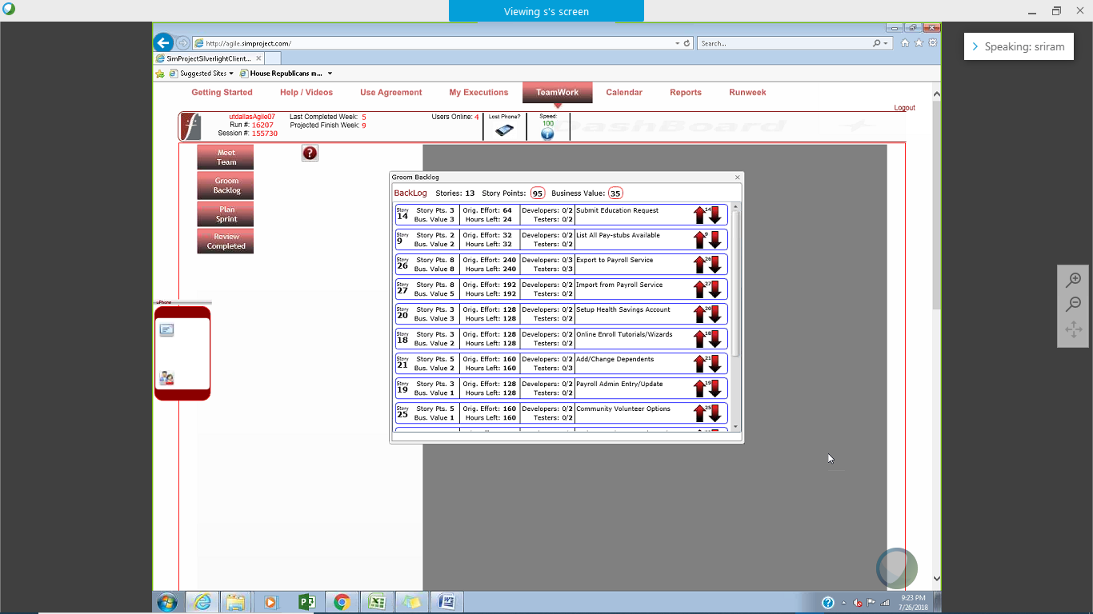

* Please explain what you did in grooming the user stories in your Product Backlog and your reasoning for these decisions **(2 Points)**:

**Answer**

Since we completed the MRF, we shifted focus on the nice to have features. The nice to have features were also calculate using Business Value/total hours (same as previous user stories) and sorted them from high-low. However, we also considered the total hours needed to complete all the user stories, so we don’t exceed the total capacity hours of the team. The uncompleted user story (user story 16) was expanded from its original size of 3 to 8. So, it got carried into Sprint 3.

**Sprint Backlog (one screen shot for both weeks)**

* Paste the screen shot of your Sprint Backlog below **(1 Point)**:

**Answer**

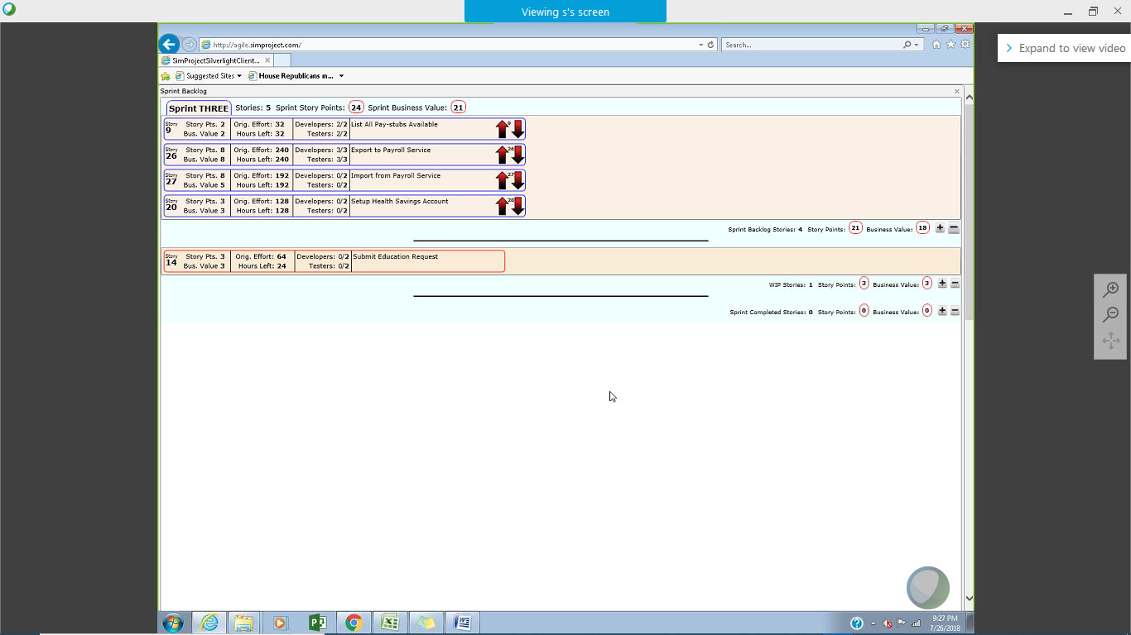

**Calendar**

* Paste the screen shot of your Calendar (one screen shot for 1st week & one for 2nd week):

1st Week Calendar Screen Shot and explain the reason why you have scheduled these meetings (if any)? **(2 Points)**

**Answer**

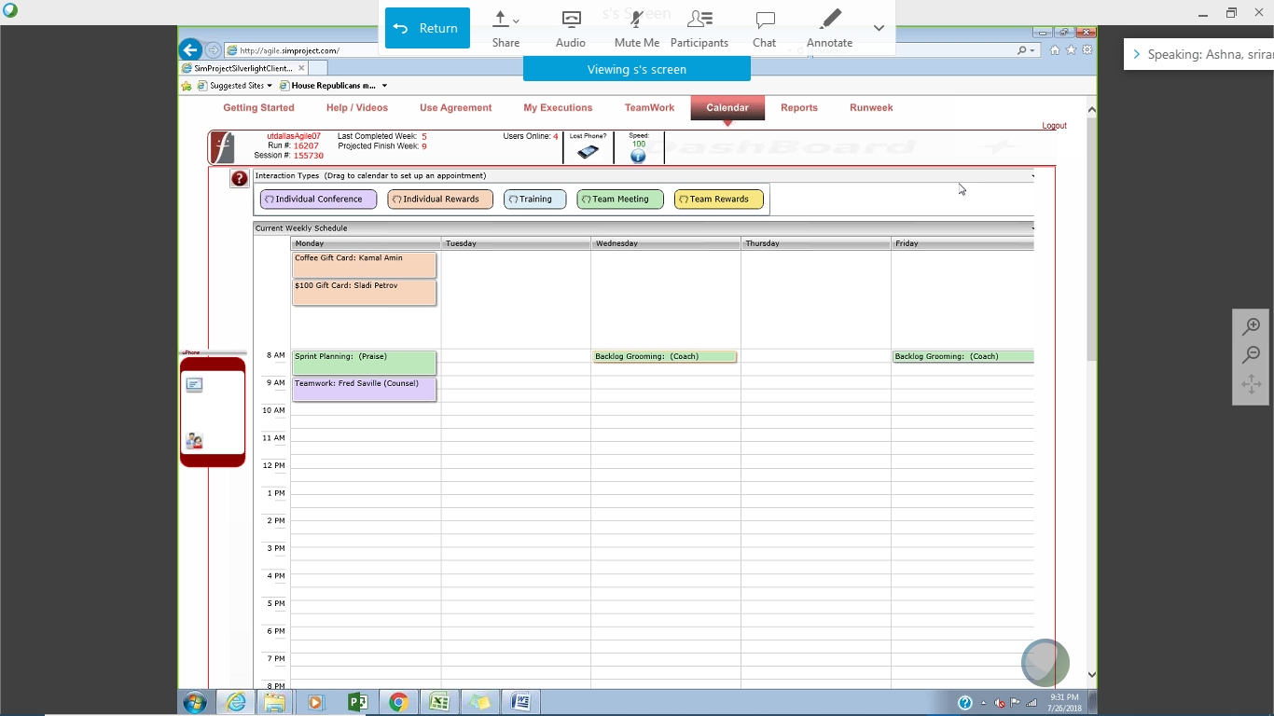

The meetings are:

* Sprint planning: To plan the product backlog items so we can get a Sprint backlog. It shows a list of all user stories expected to be completed by the team.
* Individual Rewards: We rewarded Kamal and Sladi for showing delivering high quality products and showing good productivity during the previous Scrum.
* Backlog Grooming: This meeting was to prepare the product backlog items for the next week.
* Teamwork Counsel: We also scheduled a counsel session with Fred because of his lack of team spirit. He was often having issues with his coworkers.

2nd Week Calendar Screen Shot and explain the reason why you have scheduled these meetings (if any)? **(2 Points)**

**Answer**

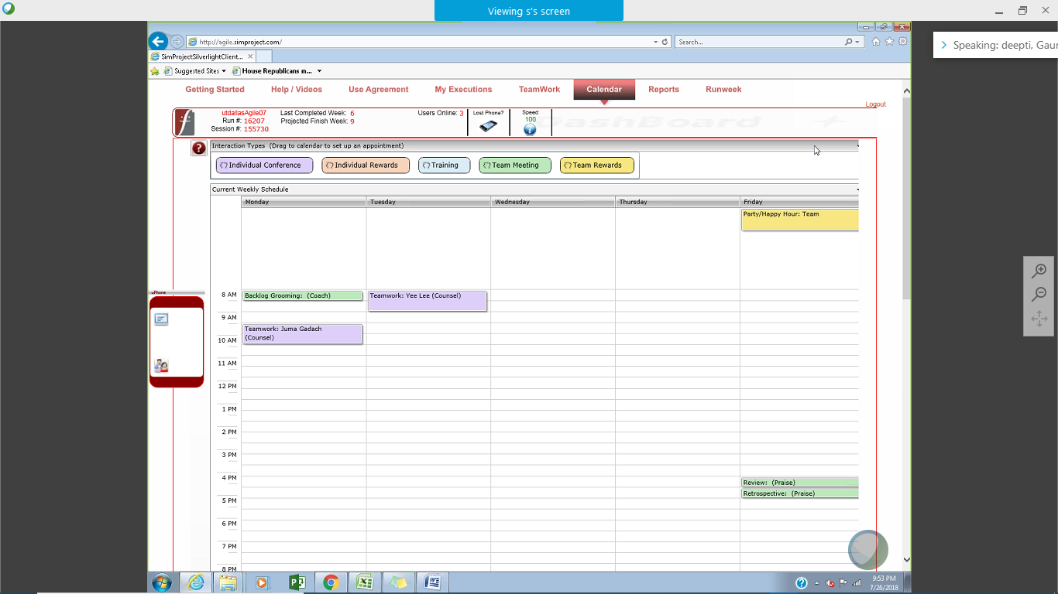

The meetings are:

* Backlog Grooming: This meeting was to prepare the product backlog items for the next week.
* Sprint Review: The review meeting was to discuss the user stories completed and discuss about the overall product.
* Sprint Retrospective: The review meeting was to see what processes to improve for the next Sprint and rectify mistakes made in the current Sprint.
* Teamwork Counsel: We scheduled counsel sessions with Juma. Juma had a personal conflict with Katina and that impacted the user story completion as she did not want to work in the same story as Katina.
* Teamwork Counsel: We scheduled counsel sessions with Yee because she wanted to work alone in a user story and not be clubbed with other team members as she felt it reduced her productivity.

**Task Board**

* Paste the screen shots of your Task Boards (one screen shot for 1st week & one for 2nd week)

1st Week Task Board Screen Shot **(1 Point)**

**Answer**

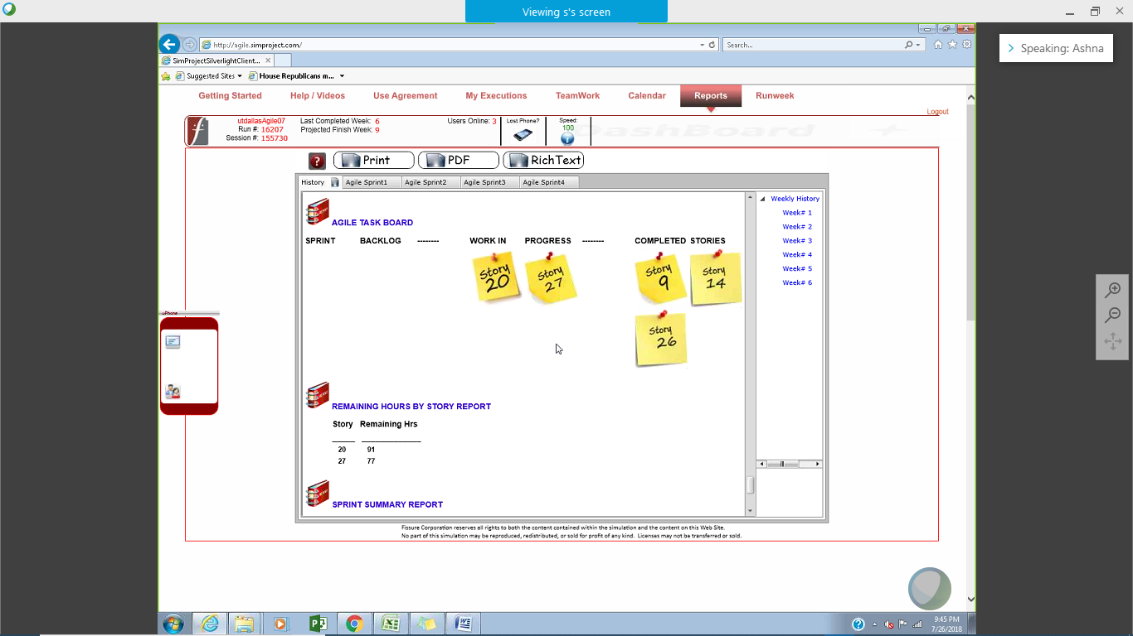

2nd Week Task Board Screen Shot **(1 Point)**

**Answer**

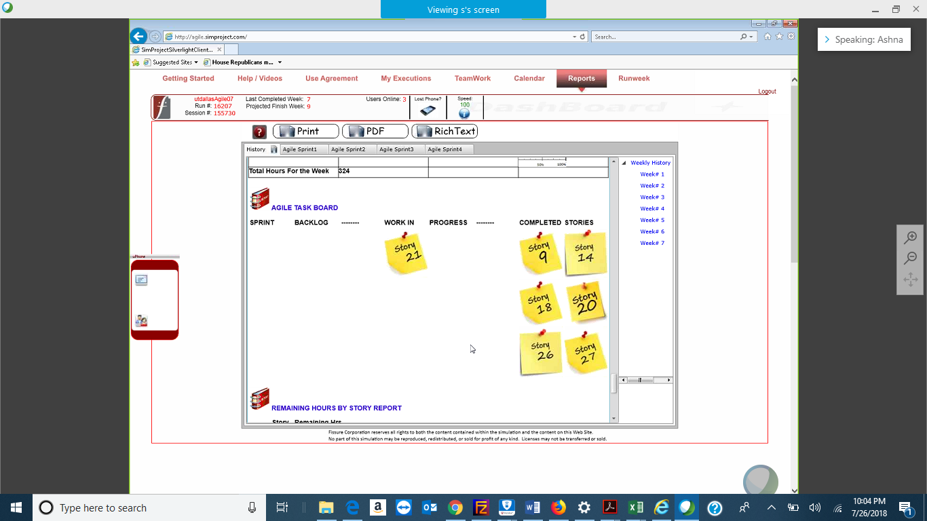

**BurnDown – EarnUp Chart**

* Be sure to complete your Burn Down – Earn Up Chart for this sprint. An Excel template has been provided for these charts.
* Paste the Sprint 3 Burn Down – Earn Up Chart below **(2 Points)**:

**Answer**

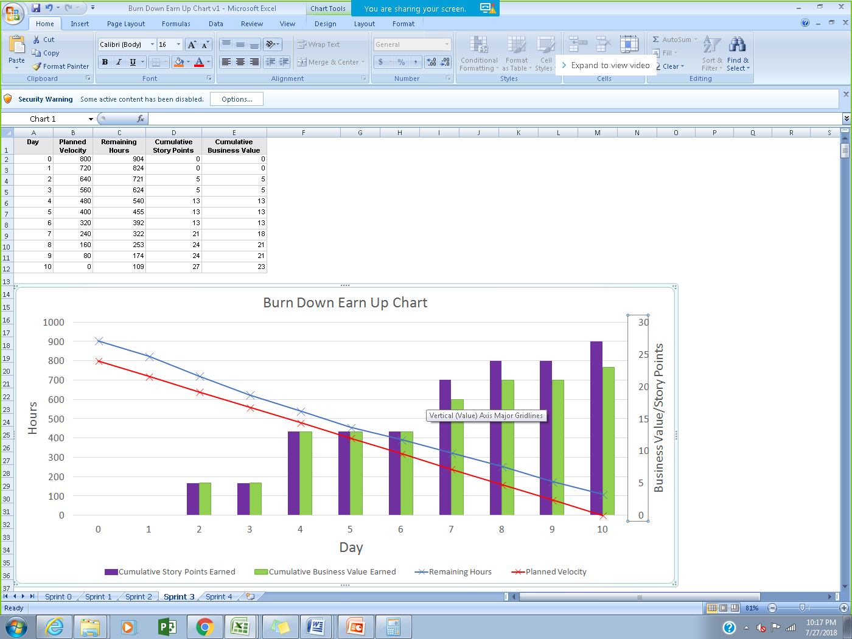

**Retrospective Meeting:**

* How did you do in this Sprint? **(2 Points)**

**Answer**

* We planned for less number of hours because Barbara had to leave the team after the first week of the current Sprint.
* We did not add another story in the middle of the sprint because we think making changes in middle of the sprint does not comply with Agile processes. An additional story was picked up from the backlog because we were done with existing planned stories.
* What changes are you planning to make in the next Sprint (if any)? **(2 Points)**

**Answer**

We need to reprioritize since the product owner Farley added 3 required and 3 optional high priority items in the product backlog. Also, some defect fixes had top priority**.**

We were planning on lesser number of user story hours as Barbara was not available.

**Answer following questions based on this Sprint:**

1. How many hours did your team complete each week in the two weeks of above Sprint?   
What is your average velocity per week (in hours), and your velocity range (in hours per week), using your lowest and highest hours/week in this project as your range? **(2 Points)**

**Answer**

In week 6: 449

In week 7: 346

Average velocity per week in hours (for Sprint 3)= 449+346/2=397.5 hours of work

Average velocity per week in hours (cumulative): 384+408+307+396+275+449+346/7 = 366.42 hours of work (We also took the velocity of Sprint 0,1,2 into the average calculation)

Velocity range: 275 to 449 hours per week

2. What is your velocity (in story points) for this Sprint? What is your velocity range (in story points) overall? Please explain. **(2 Points)**

**Answer**

We delivered 27 points in this sprint. Overall velocity range = 22 to 27

3. Based on the current status of your project, do you believe that you will be able to complete the mandatory (or required) stories in the product backlog within the remaining sprints?  Explain your answer. **(2 Points)**

**Answer**

We have already delivered mandatory stories and they have been accepted by the product owner.

4. Based on the current status of your project, do you believe that you will be able to complete all stories in the product backlog within the remaining sprints? Explain your answer. **(2 Points)**

**Answer**

No. From Sprint 1, 2 and 3 our average velocity is 25.3. In 4 sprints, we will only be able to deliver around 101.2 story points. Delivering all stories requires work on 145 story points.

**Sprint 4 - Week 8 & Week 9 (Possible Points: 24)**

**Product Backlog (one screen shot for both weeks)**

* Paste the screen shot of your Product Backlog below **(1 Point)**:

**Answer**

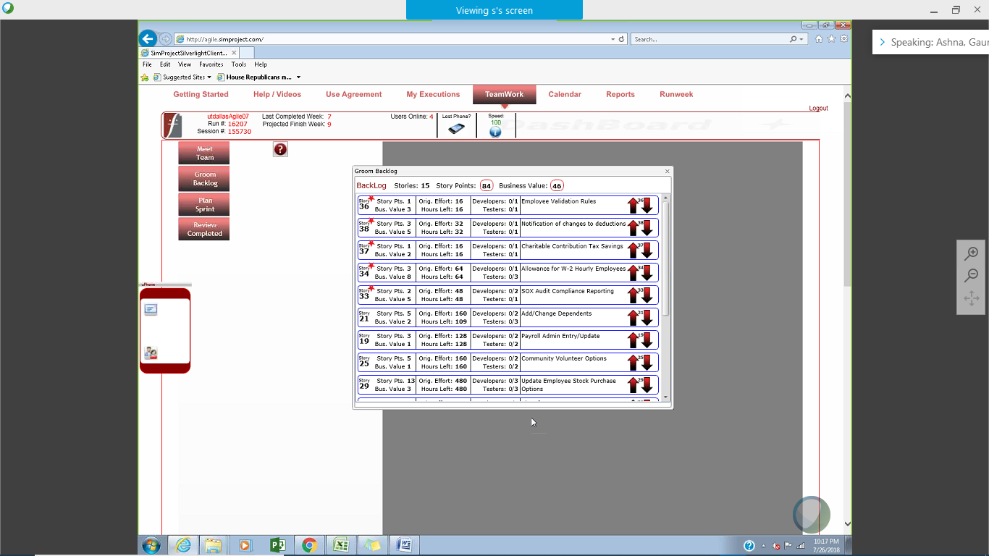

* Please explain what you did in grooming the user stories in your Product Backlog and your reasoning for these decisions **(2 Points)**:

**Answer**

Farley added critical defects to this sprint. These were added in form of high priority user stories. The defects were prioritized based on business value/total hours. Additional nice to have story points were added to cover for the remaining hours available. Further, Barbara left the project due to which we had to include lesser work load.

**Sprint Backlog (one screen shot for both weeks)**

* Paste the screen shot of your Sprint Backlog below**(1 Point)**:

**Answer**

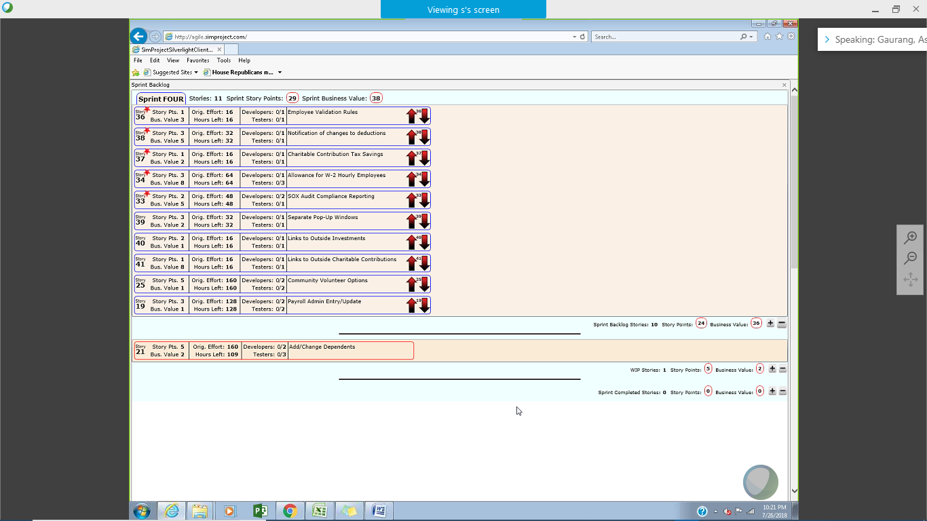

**Calendar**

* Paste the screen shot of your Calendar (one screen shot for 1st week & one for 2nd week):

1st Week Calendar Screen Shot and explain the reason why you have scheduled these meetings (if any)? **(2 Points)**

**Answer**

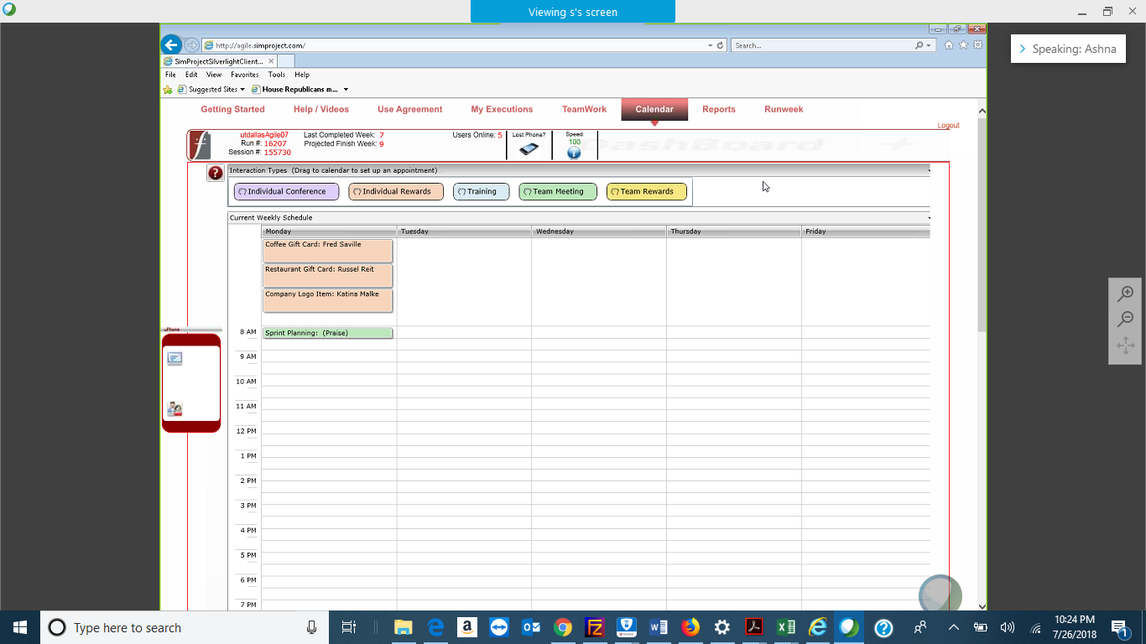

The meetings are:

* Sprint planning: To plan the product backlog items so we can get a Sprint backlog. It shows a list of all user stories expected to be completed by the team.
* Individual Rewards: We rewarded Fred for showing an improvement in his work and working better with the development team.
* Individual Rewards: We rewarded Russel for his consistent performance across all the previous sprints
* Individual Rewards: We rewarded Katina for her contribution to the team and being proactive.

2nd Week Calendar Screen Shot and explain the reason why you have scheduled these meetings (if any)? **(2 Points)**

**Answer**

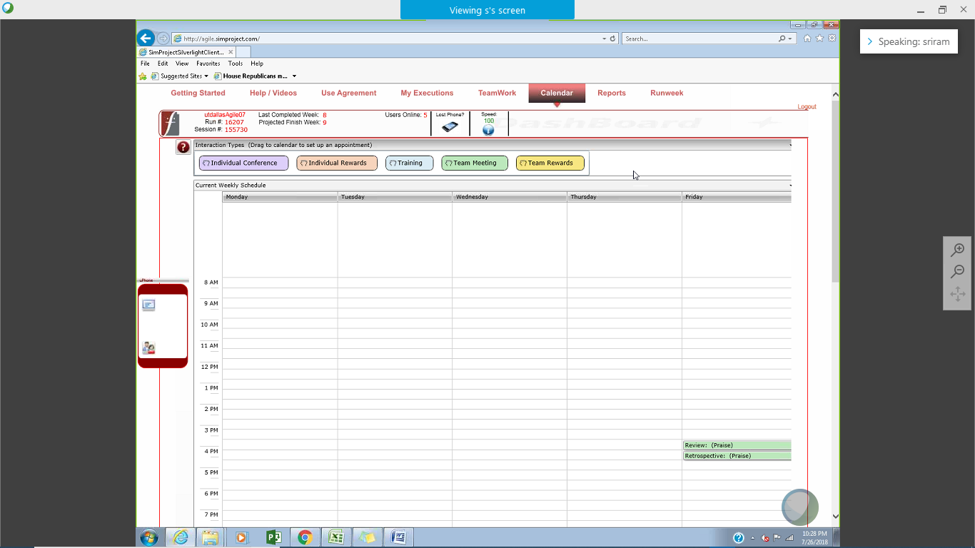

The meetings are:

* Sprint Review: The review meeting was to discuss the user stories completed and discuss about the overall product.
* Sprint Retrospective: The review meeting was to see what processes to improve for the next Sprint and rectify mistakes made in the current Sprint.
* Since this was the last Sprint there were no other meeting scheduled.

**Task Board**

* Paste the screen shots of your Task Boards (one screen shot for 1st week & one for 2nd week):

1st Week Task Board Screen Shot **(1 Point)**:

**Answer**

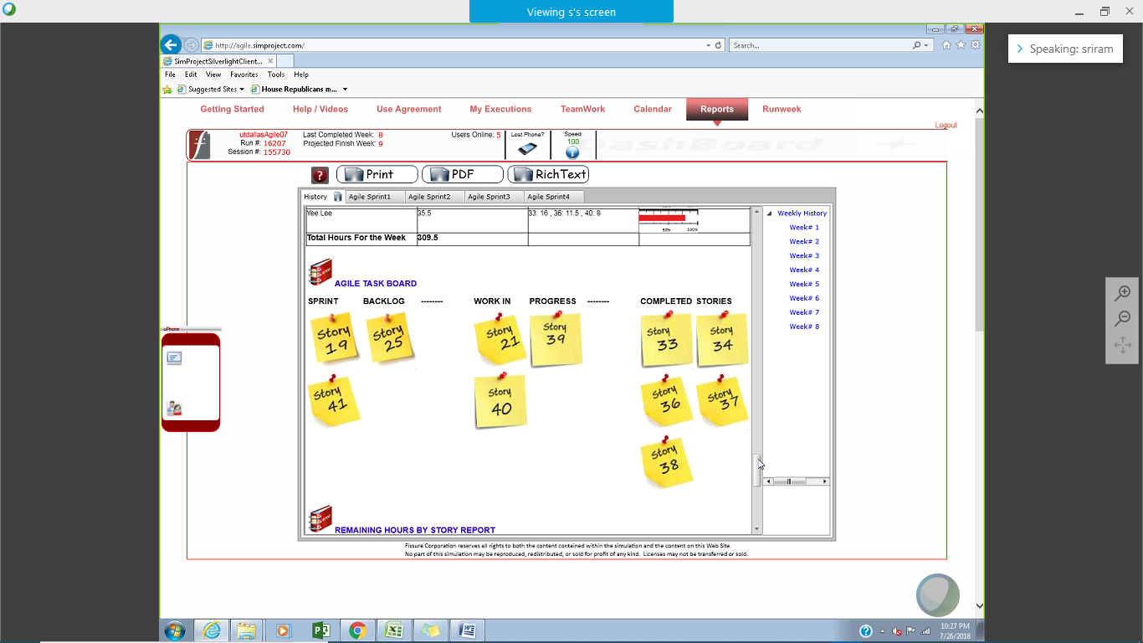

2nd Week Task Board Screen Shot **(1 Points)**:

**Answer**

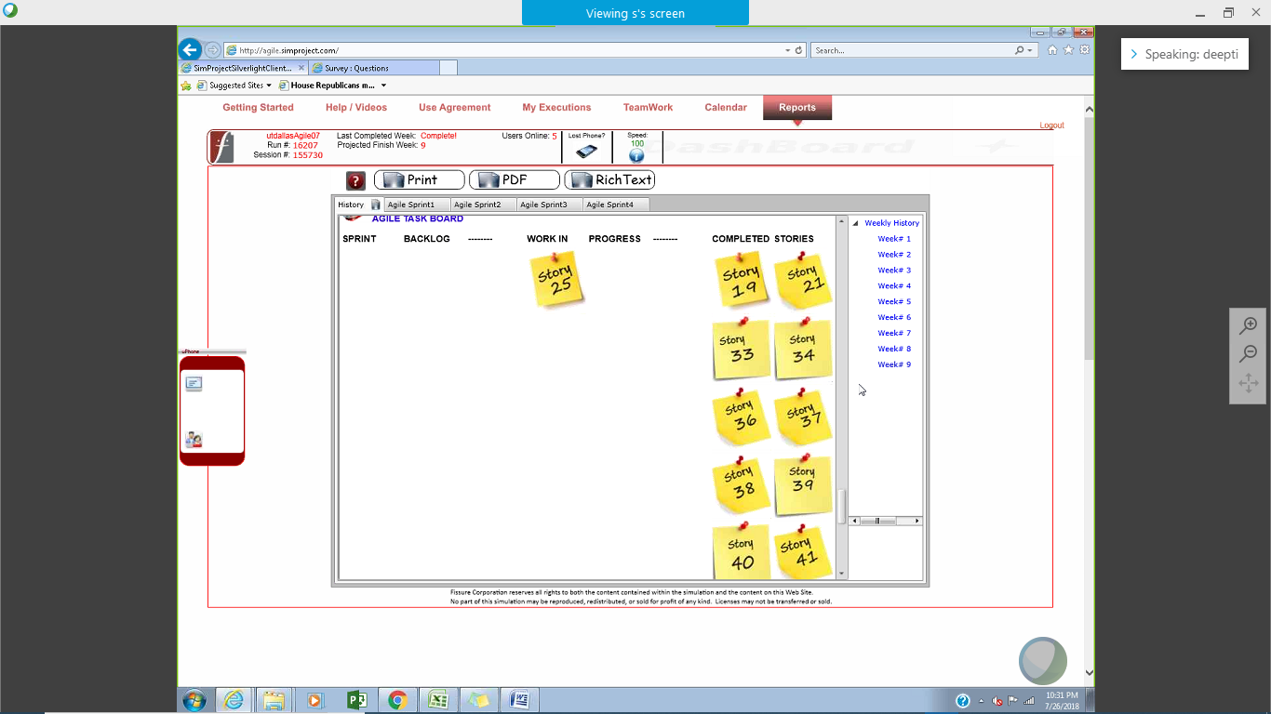

**BurnDown – EarnUp Chart**

* Be sure to complete your Burn Down – Earn Up Chart for this sprint. An Excel template has been provided for these charts.
* Paste the Sprint 4 Burn Down – Earn Up Chart below **(2 Points)**:

**Answer**

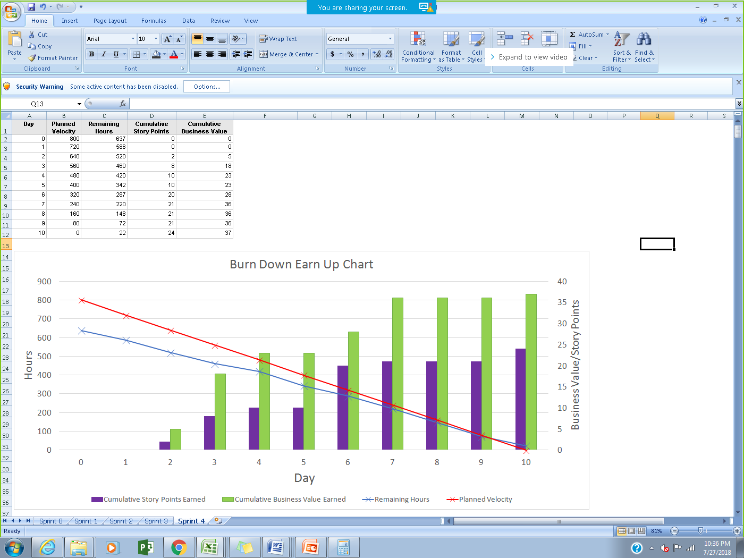

**Retrospective Meeting:**

* How did you do in this Sprint? **(2 Points)**

**Answer**

We finished user story 21 first which was partially worked on during the last sprint

Then our top priority was to complete the defect user stories (top priority). Upon completion we worked on the additional required stories.

* Provide a critique of your performance. Discuss your performance, accomplishments and challenges in managing this project **(2 Points)**:

**Answer**

Performance and Accomplishments:

* We prioritized user stories based on business values, story points and total hours.
* We had a list of MRF (Must have), Nice to have and Won’t have user stories.
* MRFs were completed in Sprint 2.
* Also Nice to have story points were completed.
* We accomplished 148 business value points during the project.
* We were able to deliver a potentially shippable product.
* Able to manage the project resources effectively and resolve issues in a timely manner.
* Provide encouragement through individual and team rewards to keep everyone motivated

Challenges:

* Team member conflicts impacted the team’s performance
* Productivity issues for few team members were handled by setting up individual meetings
* Managing expectations or product owner and CEO
* Convince product owner not to change the Sprint backlog during the Sprint execution phase.
* Tackling uncertainty in terms of resource availability.
* Finding the right balance between work and personal time off during the Sprint for the employees.

**Answer following questions based on this Sprint:**

1.  How many hours did your team complete each week in the two weeks of this Sprint?   
What is your average velocity per week (in hours), and your velocity range (in hours per week), using the highest and lowest hours/weeks throughout this project as the range? **(2 Points)**

**Answer**

In week 8: 295

In week 9: 273

Average velocity per week in hours (for Sprint 4)= 295+273/2=284 hours of work

Average velocity per week in hours (cumulative): 384+408+307+396+275+449+346+295+273/9 = 348.11 hours of work (We also took the velocity of Sprint 0,1,2 & 3 into the average calculation)

Velocity range: 273 to 449 hours per week

2. What is your velocity (in story points) for this Sprint? What is your velocity range (in story points) overall? Please explain. **(2 Points)**

**Answer**

In this sprint, we delivered 24 story points. Overall range = 22 to 27

3. Based on the current status of your project, were you able to complete the mandatory (or required) stories in the product backlog?  Explain your answer. **(2 Points)**

**Answer**

We have already delivered mandatory stories and they have been accepted by the product owner including the defects added by the product owner.

4. Based on the current status of your project, were you able to complete all stories in the product backlog? Explain your answer. **(2 Points)**

**Answer**

No. If Farley had not added more stories to our backlog we might have been able to pick up more user stories. Out of all the user stories in our product backlog, we could not deliver 4 stories.

Farley added critical defects to this sprint. These were added in form of high priority user stories and were completed during this Sprint.